 | BAHRIA UNIVERSITY, (Karachi Campus)  Department of Software Engineering  Assignment 4 - Spring 2025

COURSE TITLE: DevOps COURSE CODE: SEN-429
Class: BSE-8 A & B Shift: Morning
Course Instructor: Sohaib Ur Rehman Time Allowed: 1 Week
Submission Date: 28th May 2025 Max. Marks: 5 Marks
Name: Muhammad Shoaib Akhter Qadri Enrollement No: 02-131212-009

Assignment Title: Securing S3 Static Website Hosting with Custom Bucket Policies [CLO5: 5 Marks]

This assignment simulates a scenario where a public static website is hosted on Amazon S3. You must ensure the site is accessible while enforcing strict security and compliance controls using custom S3 bucket policies generated via the AWS Policy Generator

Tasks:
- Static Website Deployment
  - Create an S3 bucket with a unique name.
  - Enable Static Website Hosting for the bucket.
  - Upload basic HTML files (index.html and error.html).
  - Ensure the website is publicly accessible and share the URL.
  - Provide screenshots of:
    - Bucket configuration
    - File upload confirmation
    - Working website in the browser
- Bucket Policy Creation Using Policy Generator
  - Use the AWS Policy Generator to create a custom S3 bucket policy.
  - The policy must explicitly Deny the following actions for all principals (*):
    - s3:DeleteObject
    - s3:PutObject
    - s3:DeleteBucket
  - Attach the policy to the bucket and test that these actions are denied.
  - Submit:
    - A copy of the JSON policy
    - Screenshots showing the policy applied
    - Attempt the denied actions and provide evidence (screenshots or error messages).
    - Explain how this policy aligns with security best practices in a DevOps or cloud environment

Submission Instructions:
- Submit a single PDF document containing:
  - Website URL
  - Required screenshots
  - JSON policy
  - Explanations

Website URL:

Required screenshots with Explanations:

First we will create a bucket and give
Bucket Name = shoaibassignment4
Bucket Type = General Purpose
Object Ownership = ACLs enabled
Object Ownership= Bucket owner preferred
Bucket Vision=Disabled
BucketKey= disabled
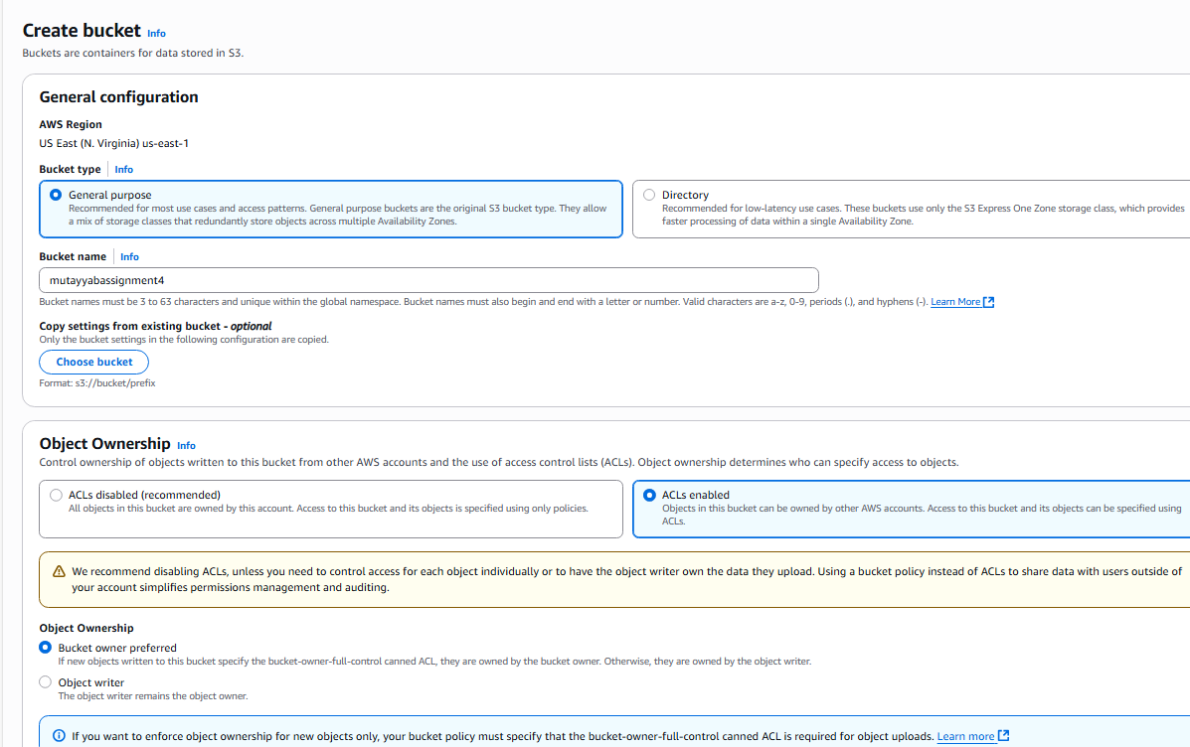

-––

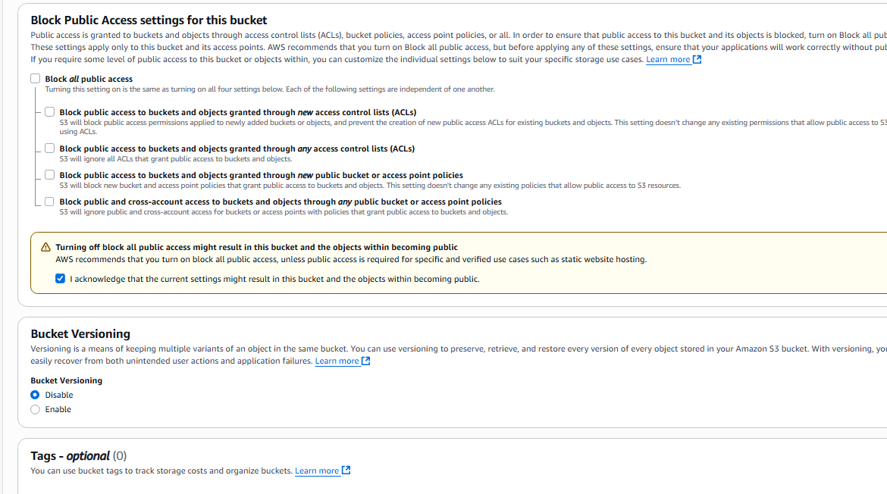

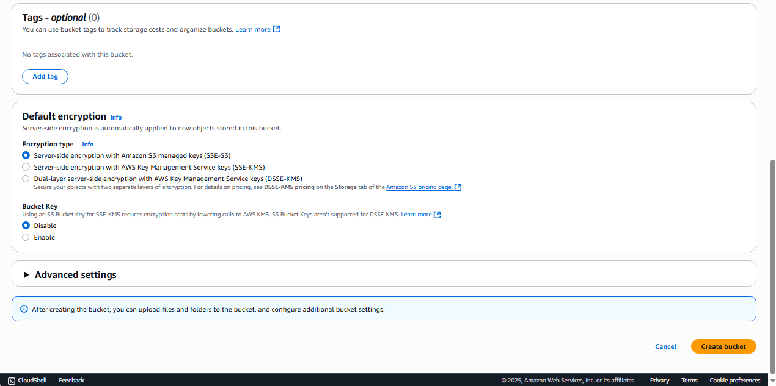

Now Bucket has been created successfully
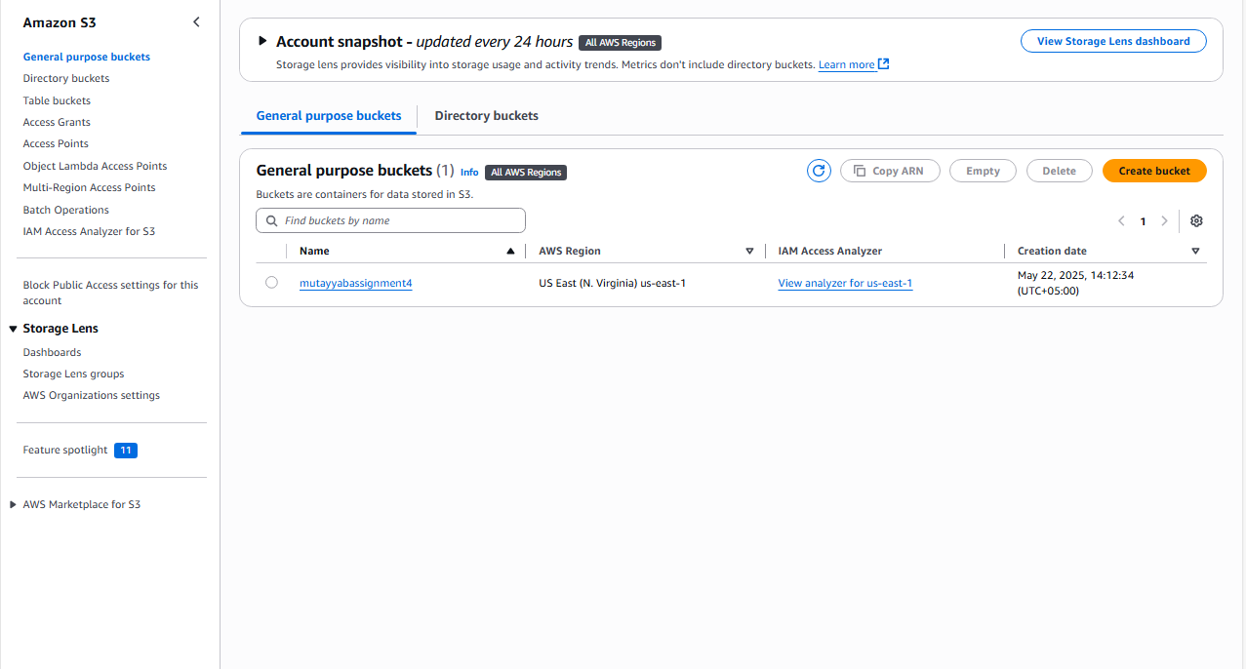

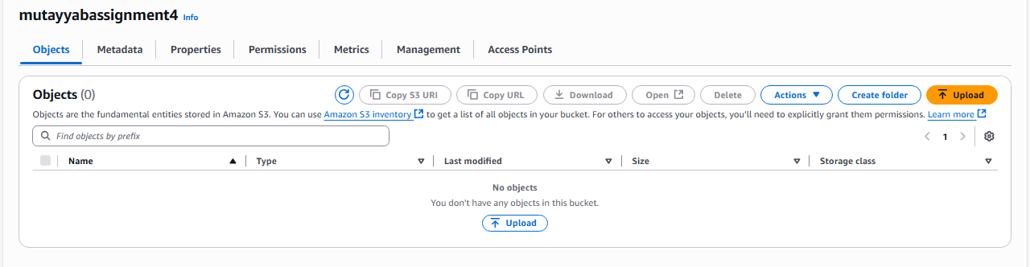
- Now Upload index.html and error.html file

- Now Select the Files using the Add File Button

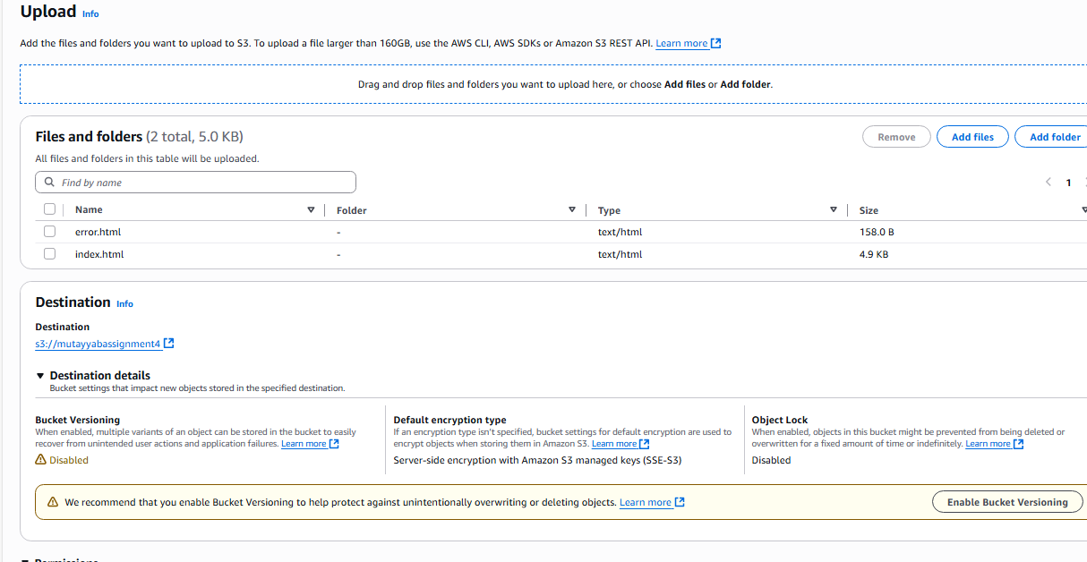

- Select the Grant-public-read access under Access Control List (ACL) Permissions.

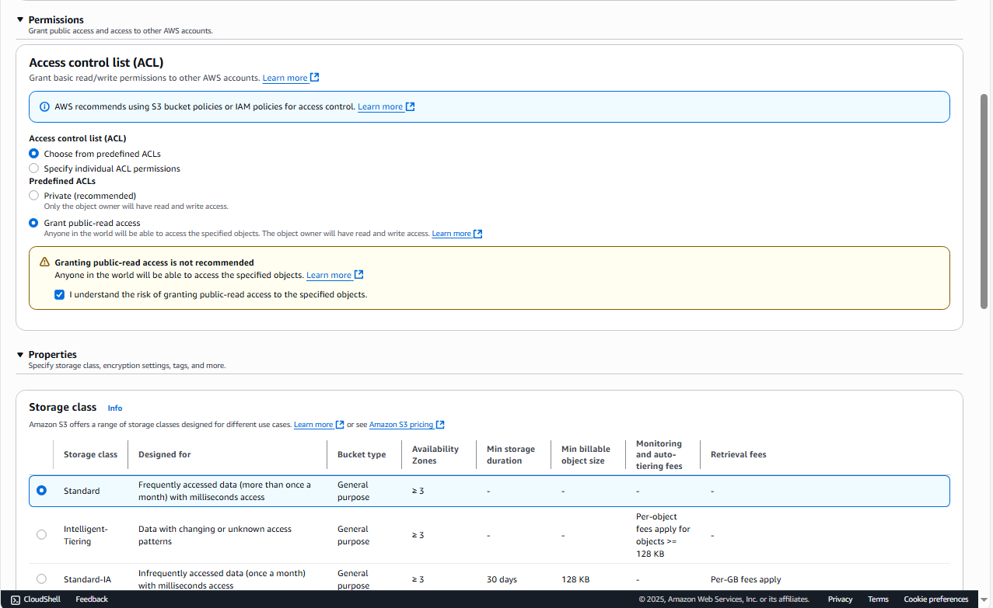

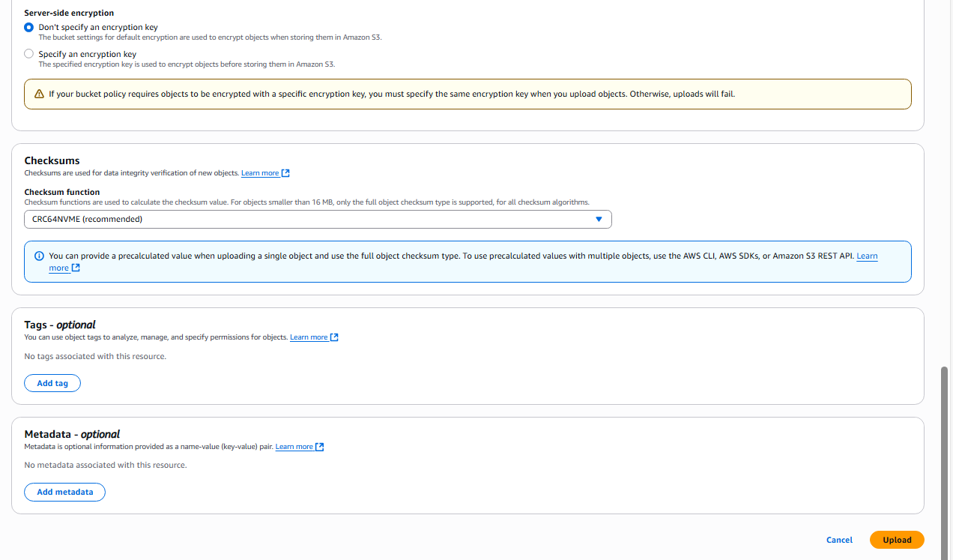

- Now files rre uploaded

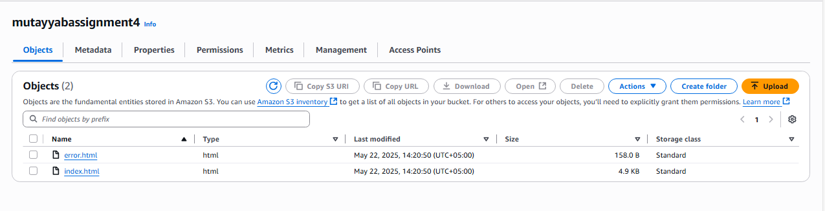

- Now Enable the Static Website Hosting Option under the properties tab
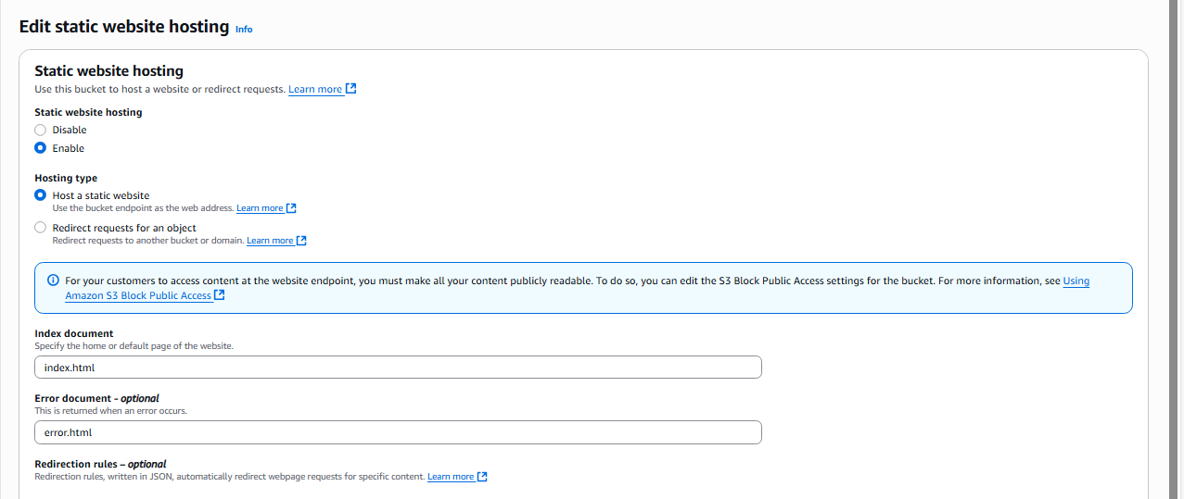

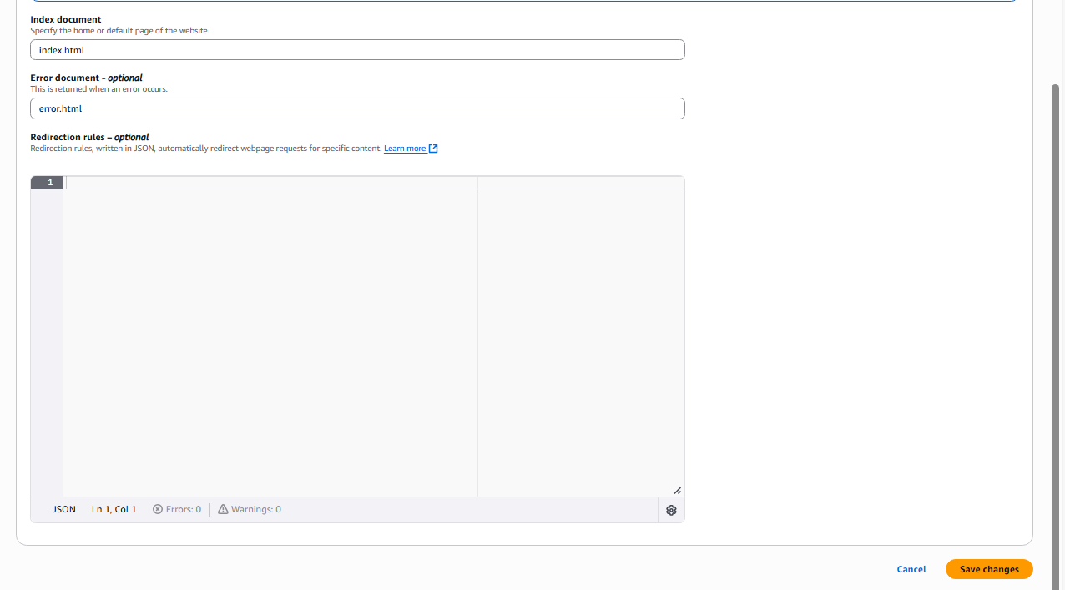

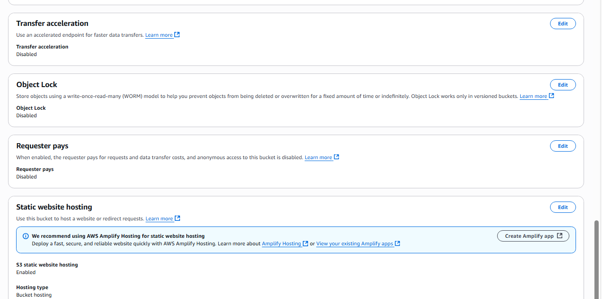

This is the URL where you can access your website.
http://shoaibassignment4.s3-website-us-east-1.amazonaws.com/

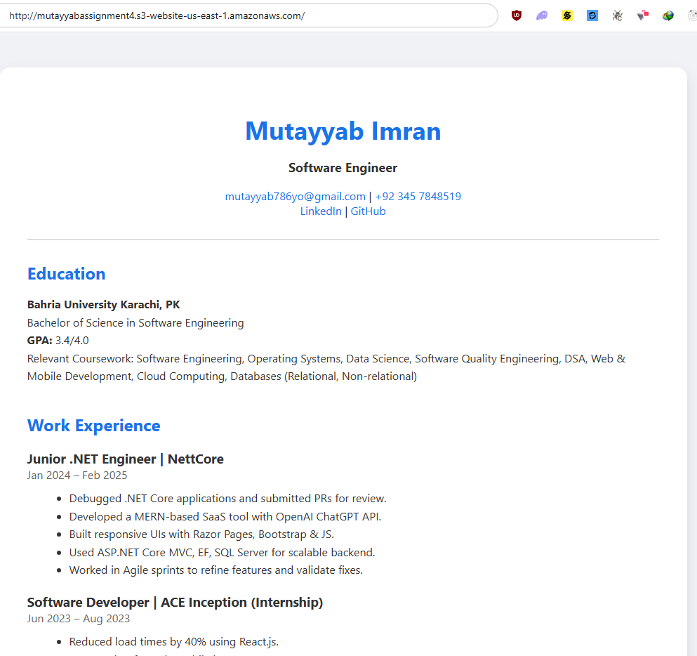

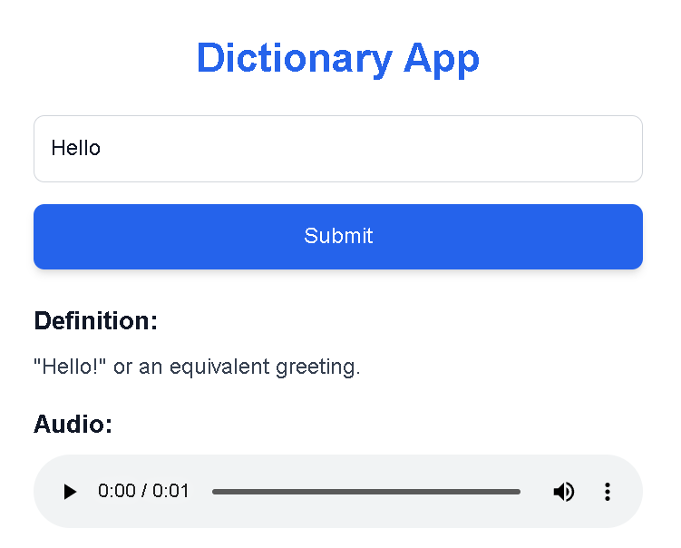

Bucket Policy Creation Using Policy Generator
Now we will create a custom S3 bucket policy using AWS Policy Generator

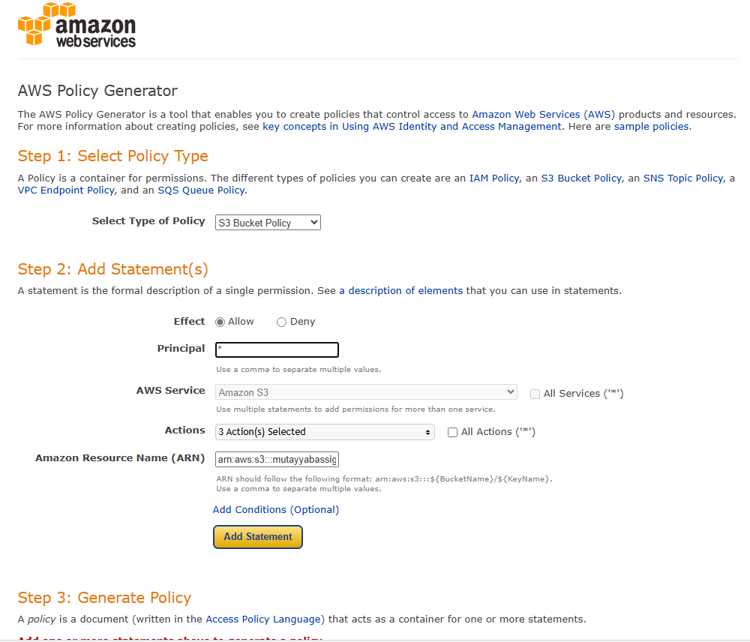

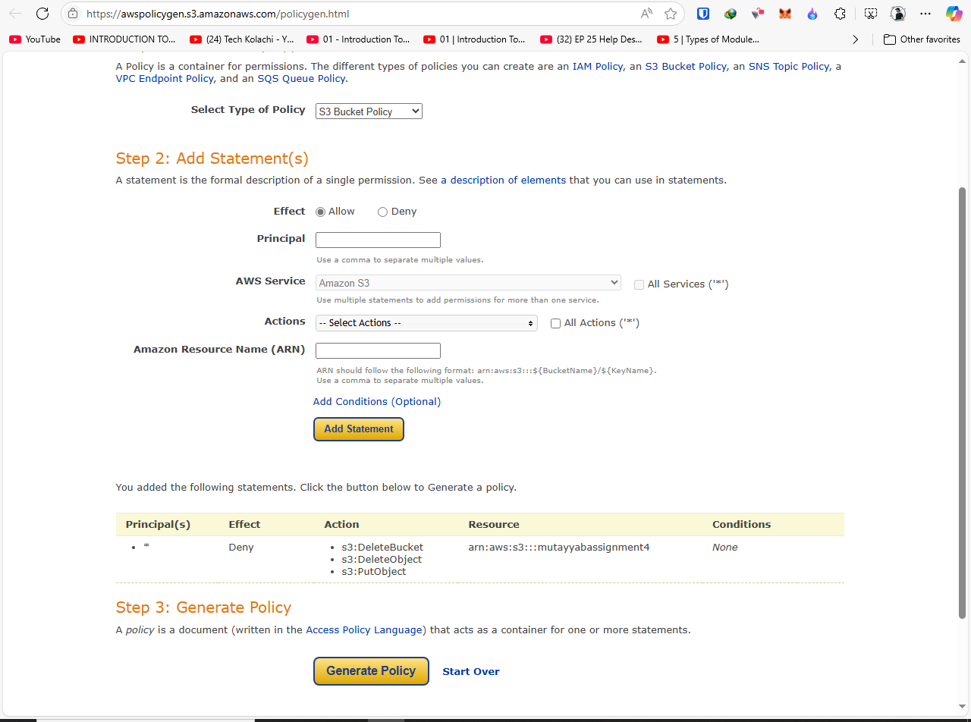
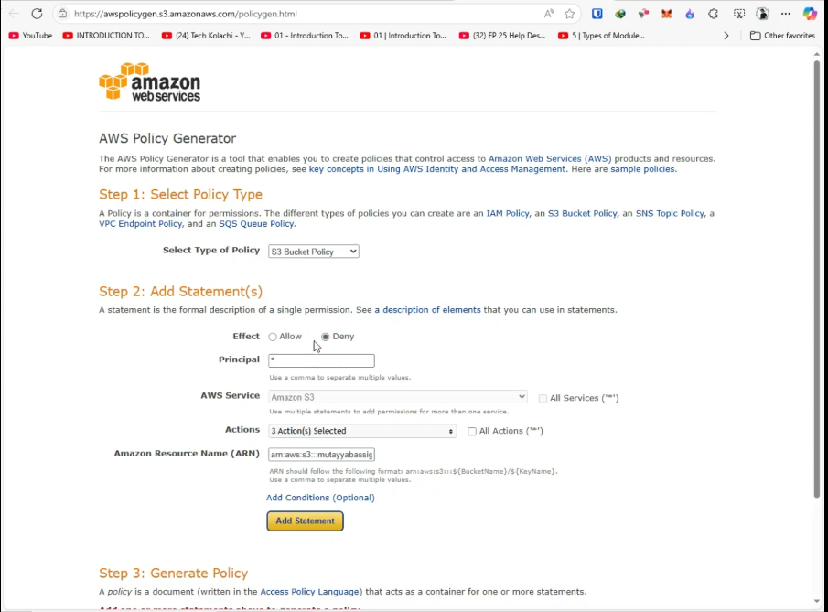

Here is the Policy JSON Document

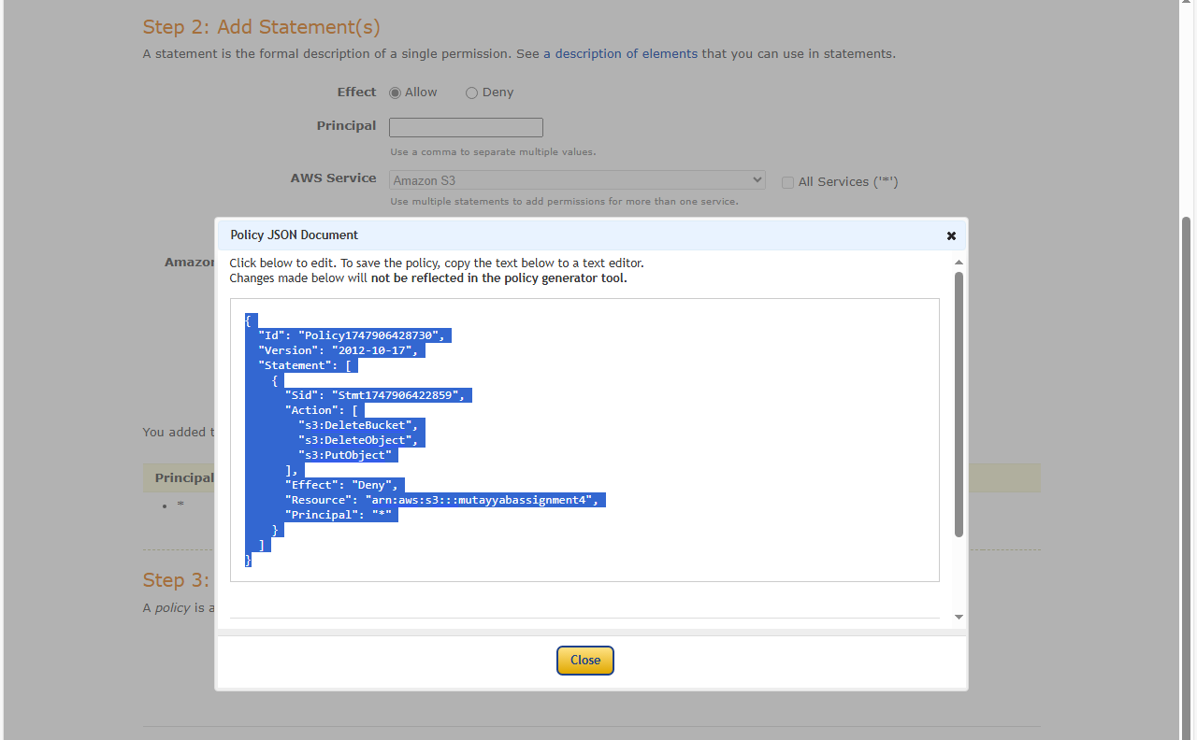

- Now we will Add the policy which we created using the AWS Policy Generator under the Permission > Bucket policy > Edit

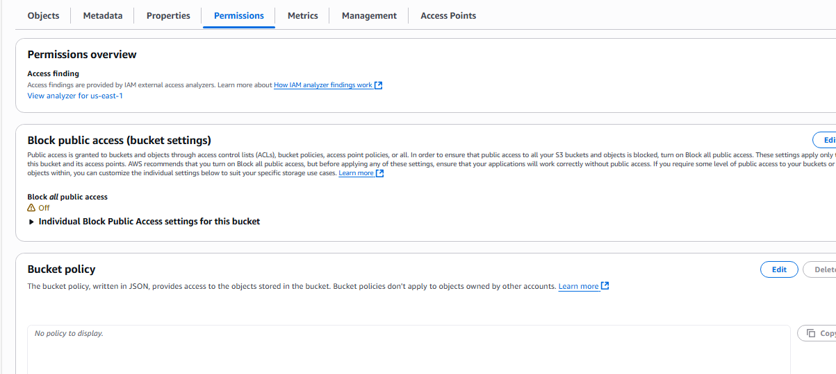

Here is the Edit Bucket Policy

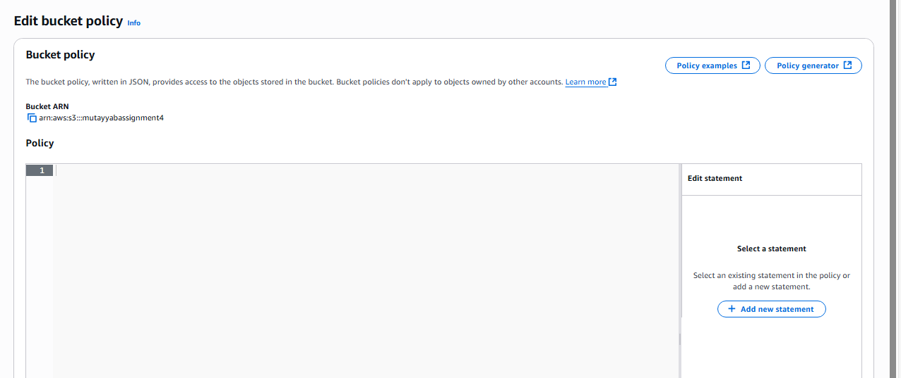

Now we are pasting policy here

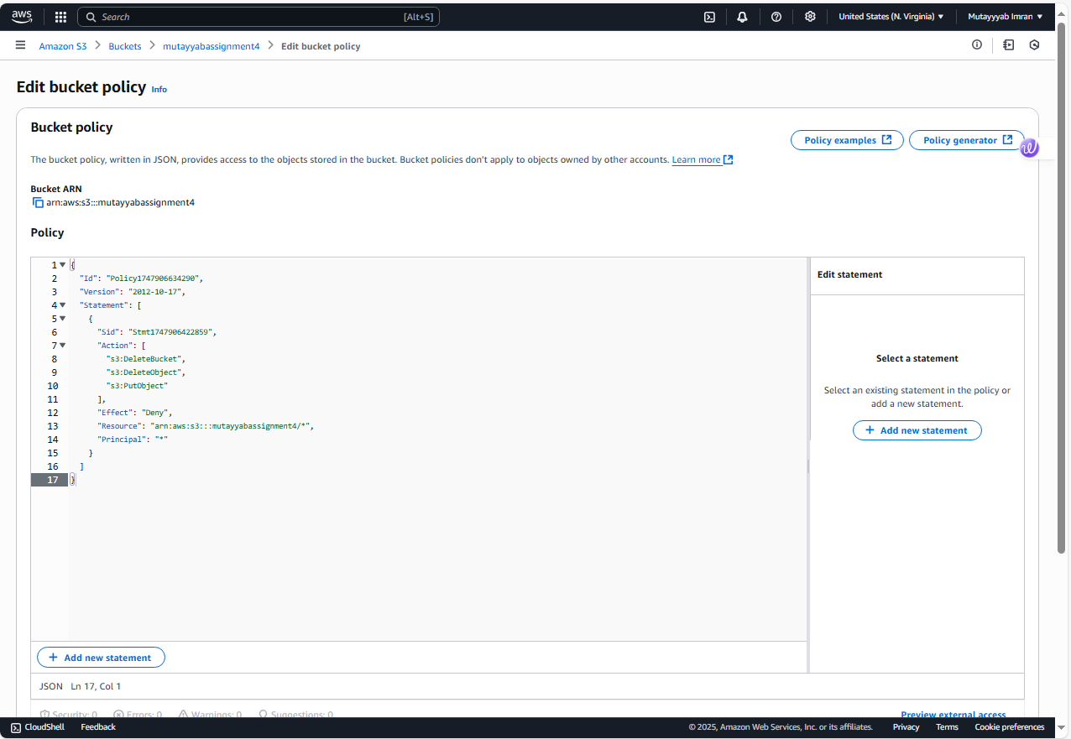

Now Bucket Policy has been successfully

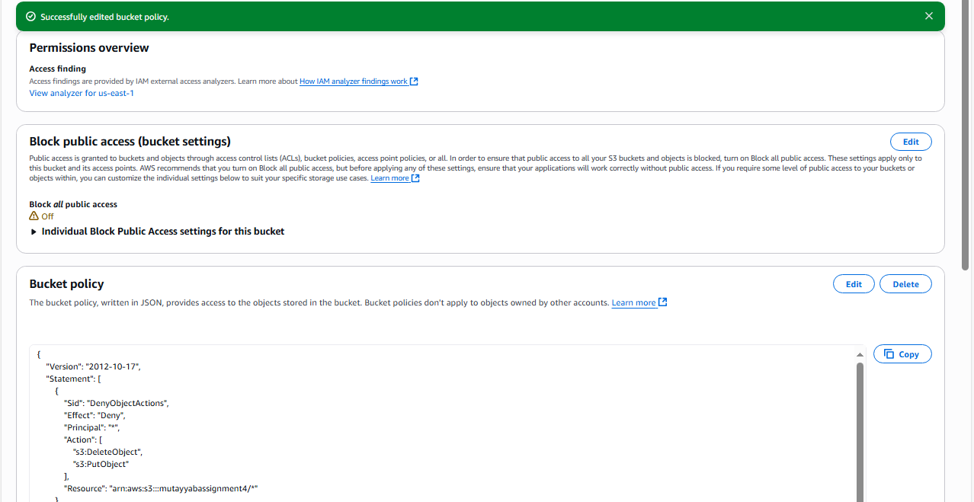

The Policy We created using the AWS Policy Generator is not working so I will rewrite the policy.
The problem is that you're trying to apply all three actions (DeleteBucket, DeleteObject, and PutObject) to the same resource pattern (arn:aws:s3:::mutayyabassignment4/*), but DeleteBucket is a bucket-level operation that can't be applied to objects (/*)
{
"Version": "2012-10-17",
"Statement": [
{
"Sid": "DenyObjectActions",
"Effect": "Deny",
"Principal": "*",
"Action": [
"s3:DeleteObject",
"s3:PutObject"
],
"Resource": "arn:aws:s3:::mutayyabassignment4/*"
},
{
"Sid": "DenyBucketDeletion",
"Effect": "Deny",
"Principal": "*",
"Action": "s3:DeleteBucket",
"Resource": "arn:aws:s3:::mutayyabassignment4"
}
]
}
Key Fixes:
- Separated the statements:
  - One for object-level actions (DeleteObject, PutObject) that need /*
  - One for bucket-level action (DeleteBucket) that must NOT have /*
- Removed the "Id" field (not required for bucket policies)
- Proper resource ARNs:
  - For objects: arn:aws:s3:::mutayyabassignment4/*
  - For bucket: arn:aws:s3:::mutayyabassignment4
Now we Will Check our policy is working or not
Uploading a file to check the PutObject Functionality under the Upload File Option.

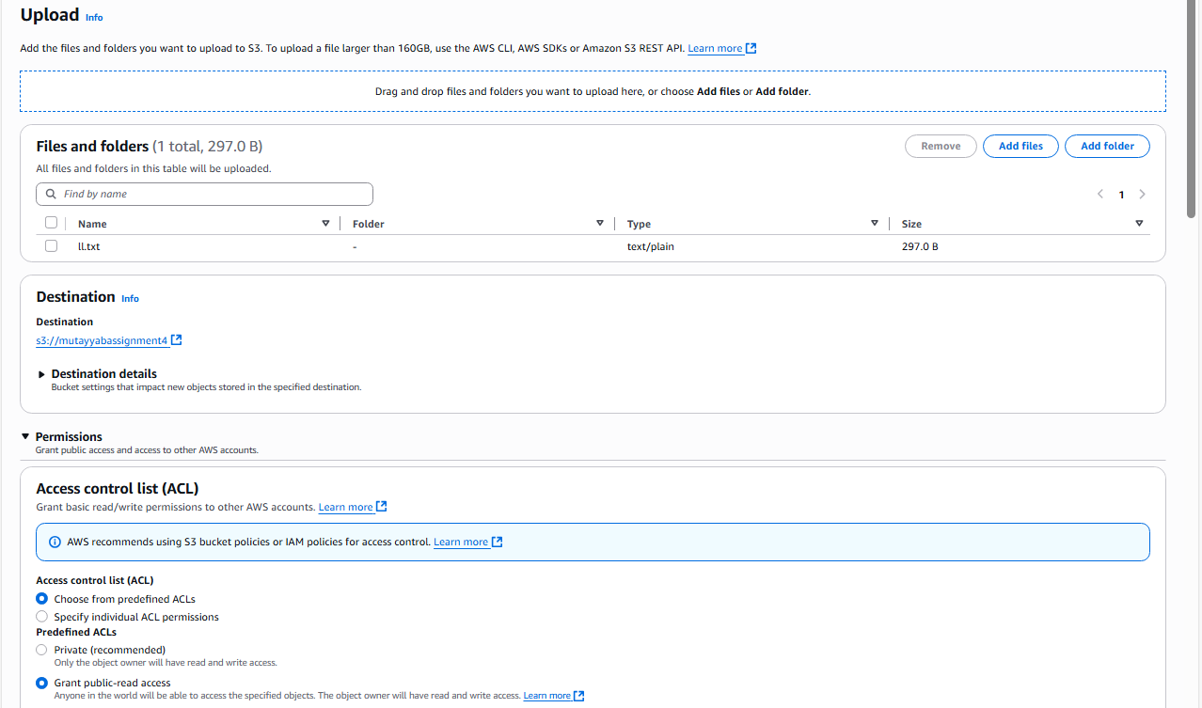

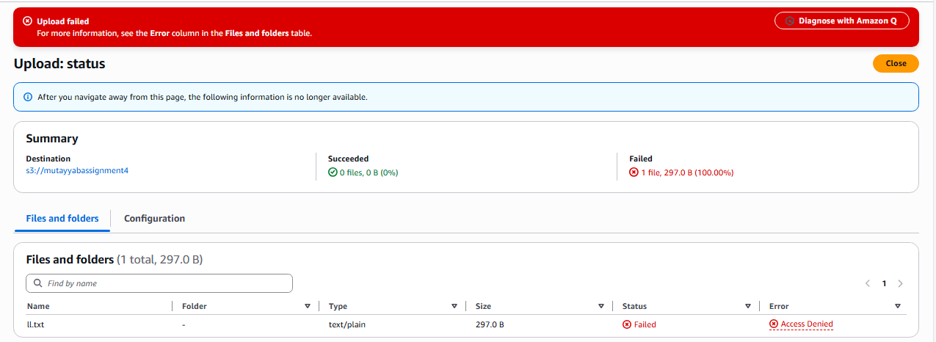

Deleting a File to check the DeleteObject Functionality under the Delete File Option.

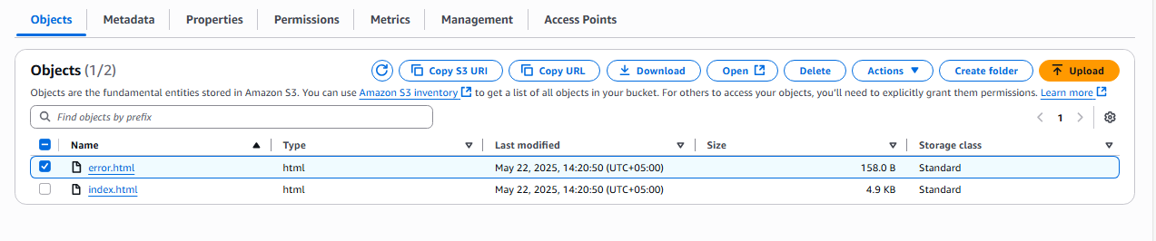

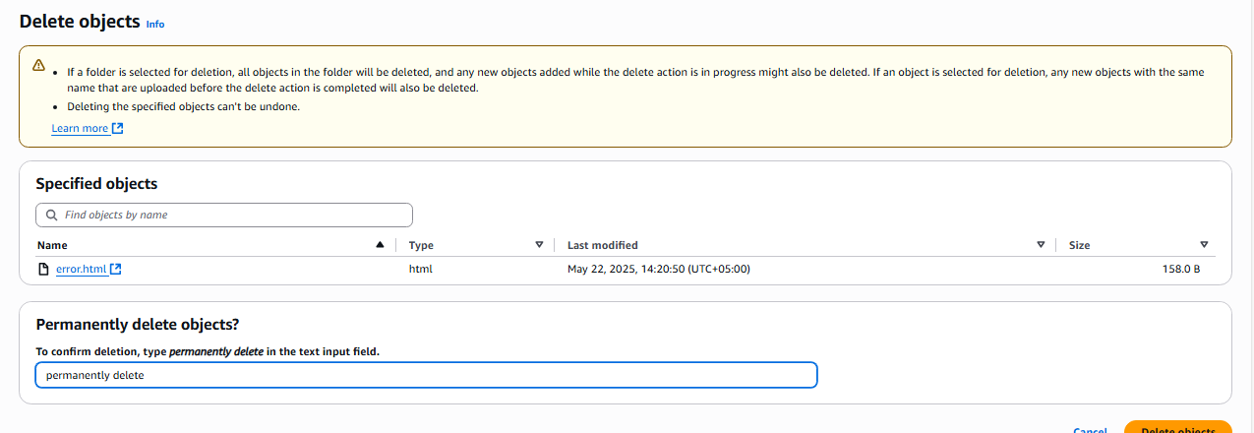

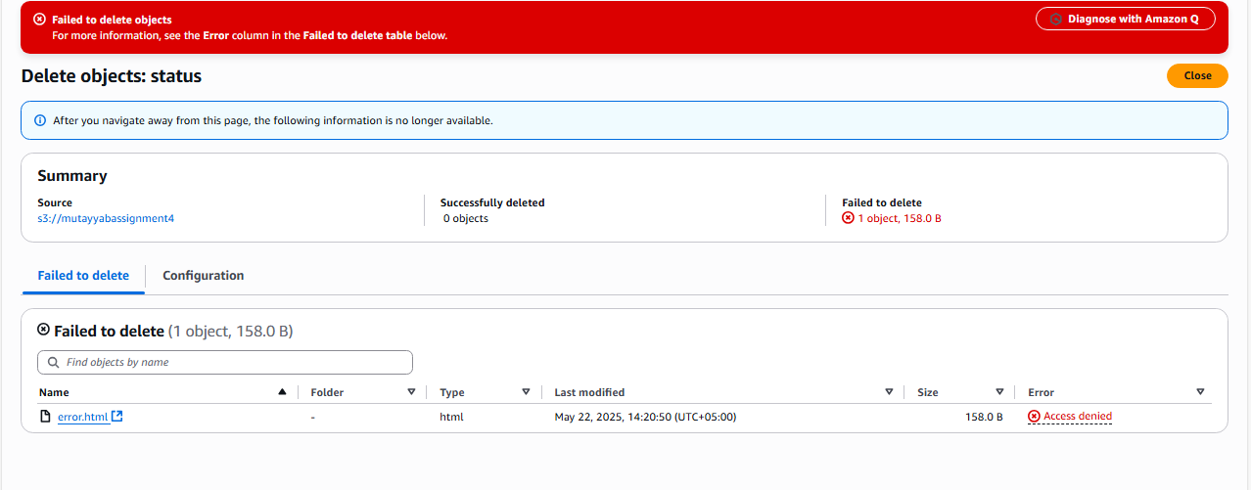

Deleting a bucket to check the DeleteBucket Functionality.

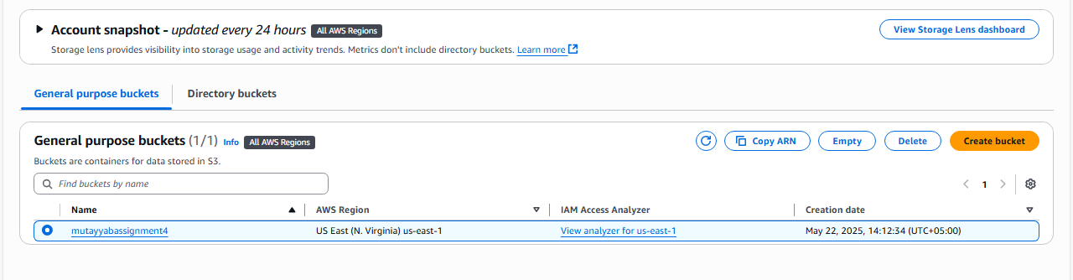

When the bucket has the data, the bucket can’t be deleted so we first empty the bucket and then try to delete our bucket.

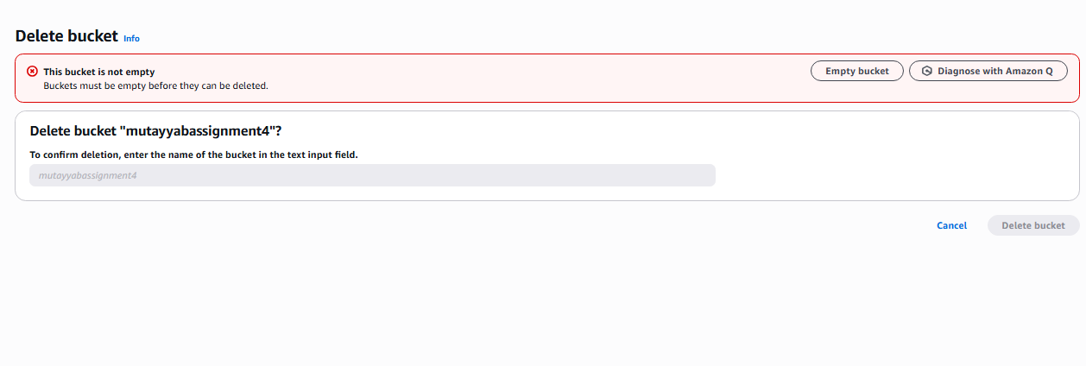

Now Empty the Bucket, Click on Empty bucket Button.

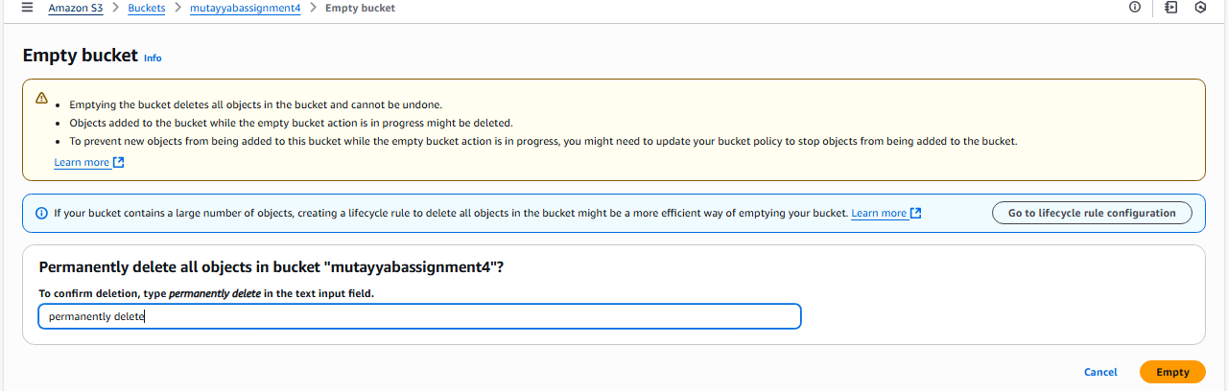

Now the bucket is empty

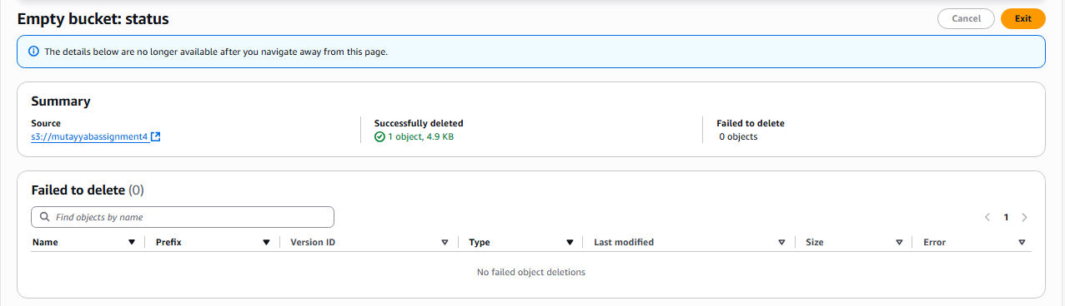

Now we will be able to delete our bucket to check the DeleteBucket policy.
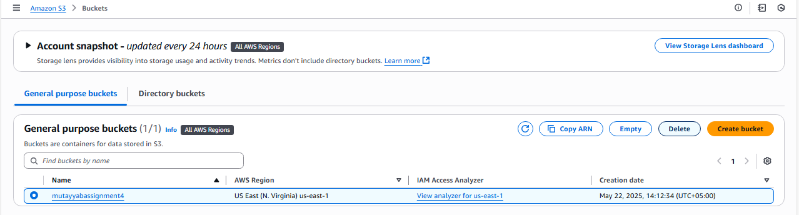

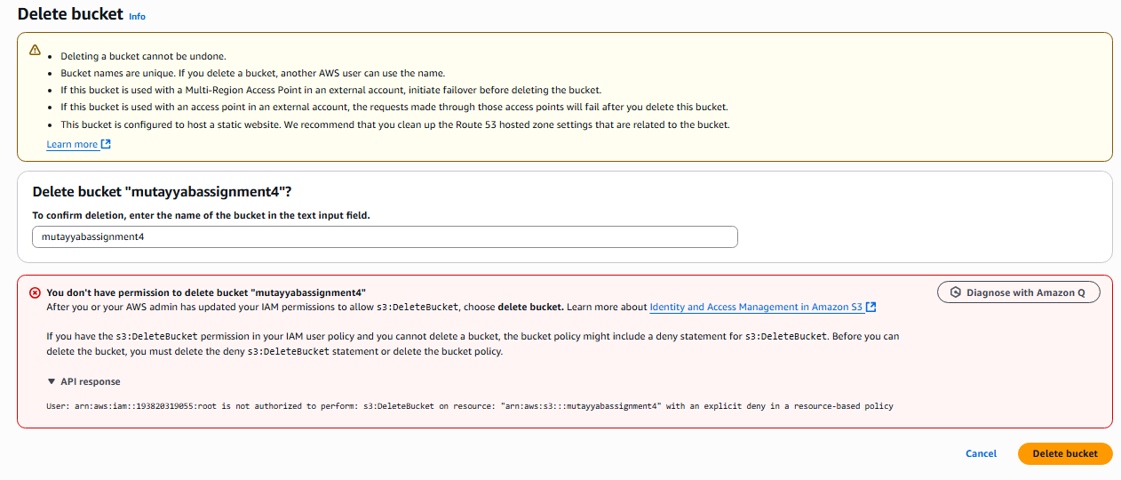

Explanation of how this policy aligns with security best practices:
- Principle of Least Privilege: The policy grants only the minimum necessary permissions (read access) while explicitly denying dangerous actions like delete operations.
- Protection Against Accidental Deletion: By denying DeleteObject and DeleteBucket actions, you prevent accidental or malicious deletion of your website content or the entire bucket.
- Prevention of Unauthorized Modifications: Denying PutObject ensures that no one can modify or overwrite your website files, protecting against defacement or injection attacks.
- Public Content Control: While allowing public read access (necessary for a website), you maintain tight control over what actions are permitted.
- Compliance: This approach helps meet compliance requirements that mandate protection against data loss or unauthorized modifications.
- DevOps Security: In a DevOps pipeline, such policies ensure that production resources can't be accidentally modified or deleted, even if credentials are compromised.
- Explicit Deny Overrides: The explicit deny statements will override any other permissions that might be granted through other policies, providing strong protection.

